**Experiment name:** Routing through multiple routers in series.

**Objectives:** To be able to route multiple routers.

**Theory:** Static routing is the process of adding IP routing information

Manually into the routing table. All routers are configured differently. A router is

similar in a switch in that it forwards packets based on address. But, instead of the

MAC address that a switch uses, a router can use the IP address. This allows the

network to go across different protocols. The most common home use for routers

is to share a broadband internet connection. The router has a public IP address

and that address is shared with the network. When data comes through the

router it is forwarded to the correct computer. There are four subnets in this

network.

**Tools:**

1. Two pc (PC0 and PC1)
2. 2960-24TT Switch(Switch0 and Switch1)
3. 1841 Router (Router0,Router1 and Router3)
4. Cisco packet tracer

**Procedures:**

1. Taking two PCs(personal computer)
2. Connecting them using 2960-24TT Switch
3. Connect the switch to 1841 router
4. Three routers are connected

**Figure using connecting wire:**

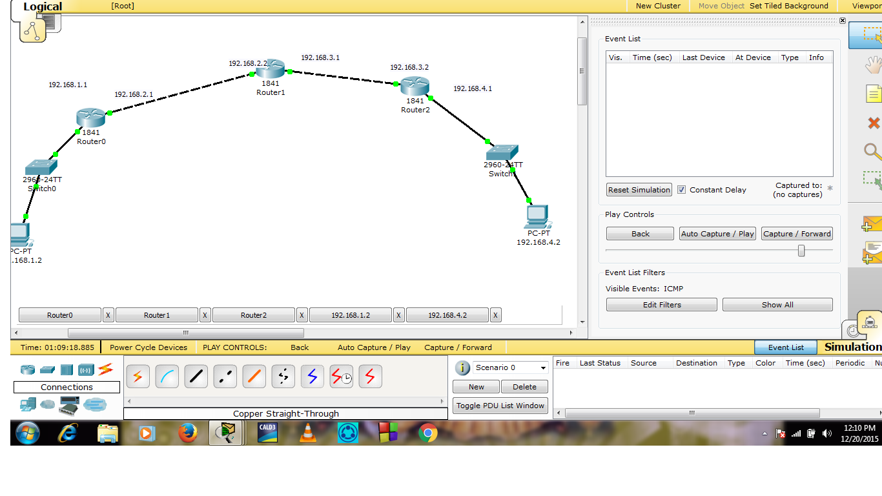

**Configuring the Router0 using following command:**

Router>en

Router#conf t

Enter configuration commands, one per line. End with CNTL/Z.

Router(config)#int fa 0/0

Router(config-if)#ip add 192.168.1.1 255.255.255.0

Router(config-if)#no shut

Router(config-if)#exit

Router(config)#int fa 0/1

Router(config-if)#ip add 192.168.2.1 255.255.255.0

Router(config-if)#no shut

Router(config-if)#

Router(config-if)#exit

Router(config)#

Router(config)#ip route 192.168.3.0 255.255.255.0 192.168.2.2

Router(config)#ip route 192.168.4.0 255.255.255.0 192.168.2.2

Router(config)#

**Figure:**

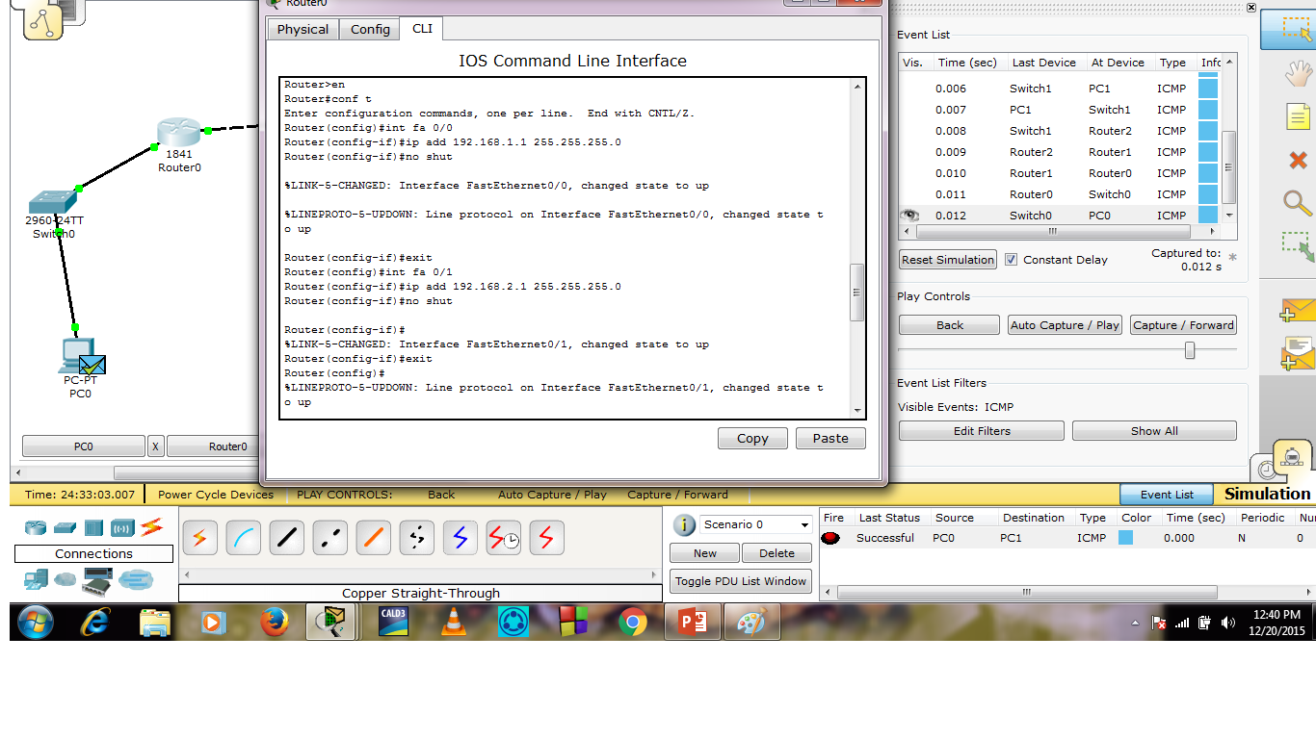

**Configuring the Router1 using following command:**

Router>en

Router#conf t

Enter configuration commands, one per line. End with CNTL/Z.

Router(config)#int fa 0/0

Router(config-if)#ip add 192.168.2.2 255.255.255.0

Router(config-if)#no shut

Router(config-if)#exit

Router(config)#int fa 0/1

Router(config-if)#ip add 192.168.3.1 255.255.255.0

Router(config-if)#no shut

Router(config-if)#

Router(config-if)#exit

Router(config)#

Router(config)#ip route 192.168.1.0 255.255.255.0 192.168.2.1

Router(config)#ip route 192.168.4.0 255.255.255.0 192.168.3.2

Router(config)#

**Figure:**

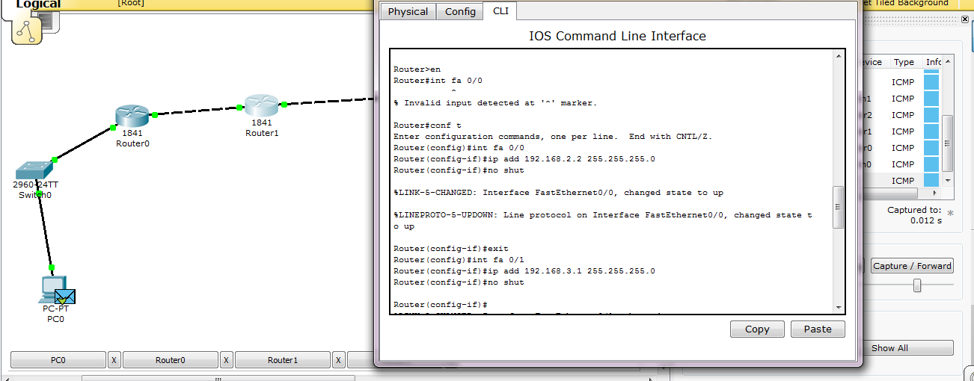

**Configuring the Router2 using following command:**

Router>en

Router#conf t

Enter configuration commands, one per line. End with CNTL/Z.

Router(config)#int fa 0/1

Router(config-if)#ip add 192.168.3.2 255.255.255.0

Router(config-if)#no shut

Router(config-if)#exit

Router(config)#int fa 0/0

Router(config-if)#ip add 192.168.4.1 255.255.255.0

Router(config-if)#no shut

Router(config-if)#exit

**Figure:**

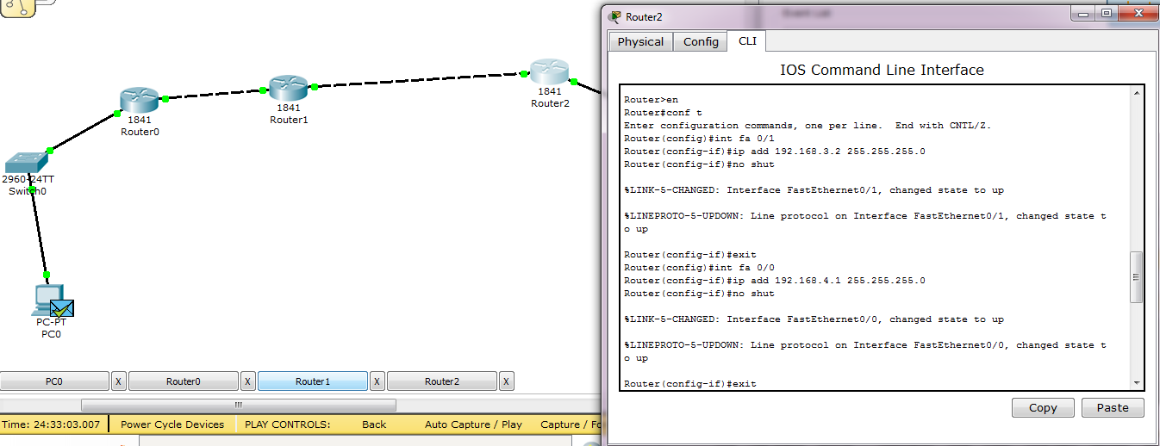

Output:

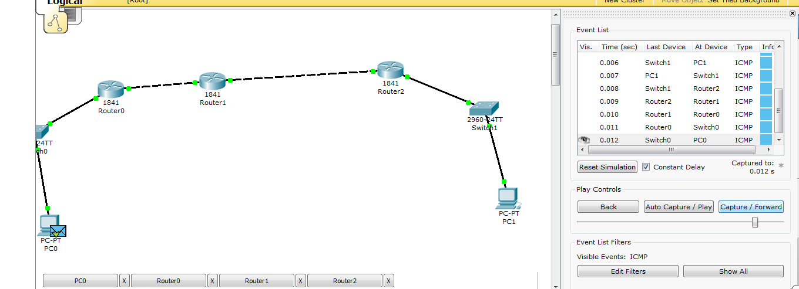

**Conclusion:**  By constructing this one can transfer packet through multiple routers from source to destination easily.